NORTHWEST TEXAS SHARED SERVICE ARRANGEMENT
P.O. BOX 240 400 EAST 7TH STREET
SUNRAY, TEXAS 79086
PHONE: (806) 948-1188 FAX: (806) 948-1189

______________________________________________________________

Dear Parents and/or Legal Guardians,
Based on feedback from the Office of Special Education Programs (OSEP), the Texas Education Agency (TEA) has updated the Notice of Procedural Safeguards and the Guide to the Admission, Review, and Dismissal Process in January & February 2021. The agencies are requesting that all parents of students who are served in special education receive an updated copy. The NWTSSA special education office is sending this letter to inform and provide you access to the most current and updated copies.
The NWTSSA is providing you three ways to have access to these new updated documents. Below you will find QR Codes, the web links, or you can contact our office at 806-948-1188 to request a hard copy to be mailed directly to you.
If you have any questions, please contact us at 806-948-1188.
Thank you.
Kim Rousser
Director for Special Education
Northwest Texas SSA
806-948-1188

https://framework.esc18.net/Documents/ARD_Guide_ENG.pdf
https://framework.esc18.net/Documents/Pro_Safeguards_ENG.pdf

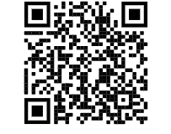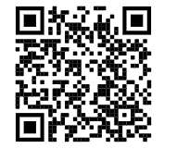
English Procedural English ARD
Safeguards Guide

